Strictly Business

Inception Phase Documents

**System Request – SRC Project**

Project Sponsor:

University of Louisville Student Recreation Center

Business Need:

This project is designed to create a more efficient way of tracking data inside the Student Recreation Center, and to create a close to paperless record keeping system.

Business Requirements:

Using a cloud-based database the Student Recreation Center staff should be able to access data regarding the facility. The members should also have access to a webpage where they can access their own membership data. The functionality that the system should have is listed below:

* Online membership payments and registration
* Tablet equipment management
* Database linked locker rentals
* Running total equipment utilization
* Email blasts

Business Value:

We expect that the Student Recreation Center will see an increase in productivity of current workers due to reducing the amount of work necessary for each small task that is done. The use of the SRC membership database will create an easy method to send email blasts when member accounts are about to expire or when membership fees are due. The email blasts would also be able to include surveys regarding the facility and its services.

Business Process Models

These process models show what the current business processes are for the SRC, and what they could be if they implement our business solutions. The biggest difference between the As-Is and the To-Be models is the transition to manually doing many of the processes to our automated solutions. Every business process that they currently practice would still exist with our solutions, but they would be more time efficient and accurate for the customers and the employees of the SRC. Using this model, the SRC as our customer, would read the current process on the left hand column, and look directly across to the right hand column to see how that process would change if we were to implement our solutions.

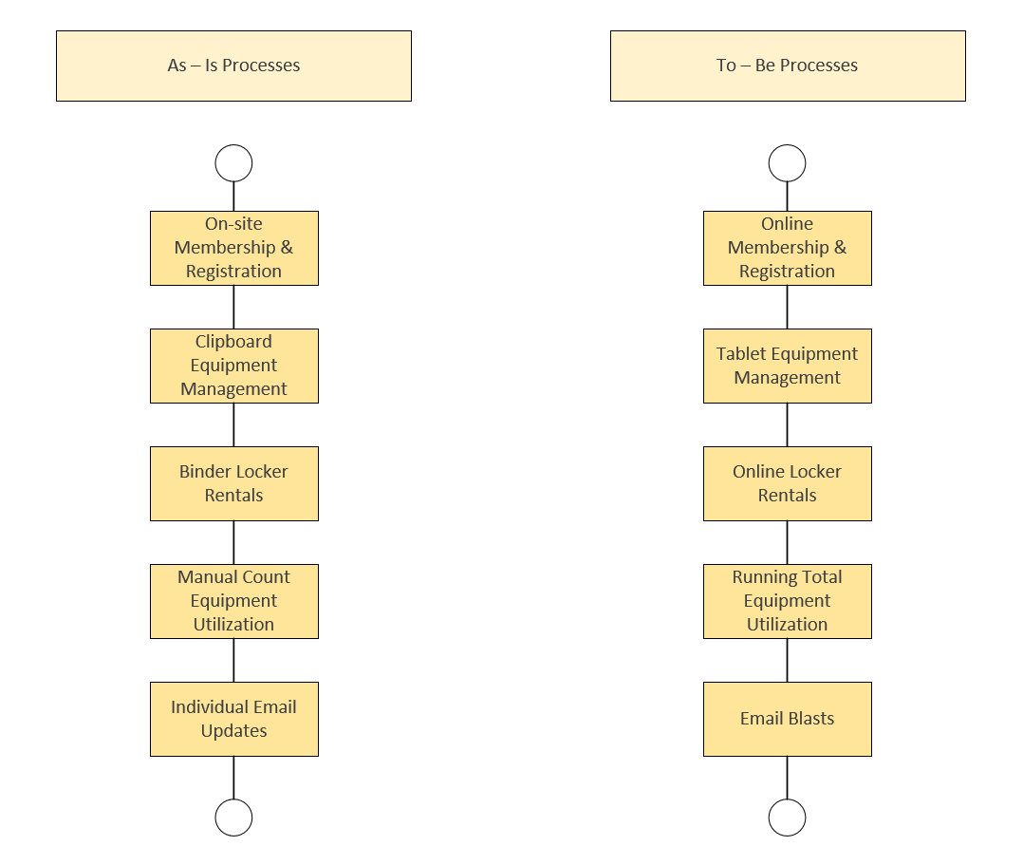

System Requirements

The following is a list of processes which the system will be able to perform. This list will comply the basic functions of the system along with the non-functional aspects such as performance.

Functional Requirements

Customers

1. The system will allow customers to view their membership online
2. The system will give the customers the ability to pay for their membership online
3. The system will allow customers to view the status of their locker rental online
4. The system will allow customers to pay for their locker rental online
5. The system will allow customers to reserve a specific locker
6. The system will allow for customers to bundle the locker and membership together by semester
7. The system will allow customers to take surveys on the site

SRC

1. The system will allow the user to track gym usage via a database
2. The system will allow the user to send out email blasts
3. The system will allow the user to send out surveys via email
4. The system will allow the user to track machine maintenance via a database
5. The system will allow the user to maintain adequate records for locker rentals and memberships
6. The system will generate reports for the user
7. The system will allow entry of usage data via a tablet
8. The system will work when the user enters a WIFI dead zone in the SRC

Database

1. The system will allow the user to add records to the database
2. The system will allow the user to remove records to the database
3. The system will allow the user to modify records to the database
4. The system will alert the user of invalid entries
5. The system will notify the user if a membership has expired
6. The system will notify the user if a locker rental has expired

Payment Systems

1. The payment system will verify the transactions are accepted
2. The payment system will be able to be integrated with the website we are creating for this project

Non-Functional Requirements

1. The system will be created using WordPress
2. The system will meet set security standards
3. The system will use a SQL database
4. The system will have a backup
5. The system will be able to recover from the backup
6. The system will be a website
7. The system will be a graphical user interface

**USE CASES**

Use cases are named, show who they pertain to, and give a description of the action taking place. These demonstrate actions people interacting with the new system will be able to take. This is also accompanied with a “Trace Matrix,” which shows which use case correlates to which system requirements.

ID: 1 | Printable Membership Form | Employee | Employee prints out completed membership forms for physical records.

ID:2 | Online Membership Form | Customer | Customer fills out the membership form from the SRC website.

ID:3 | Online Locker Form | Customer | Customer fills out the locker rental form from the SRC website.

ID:4 | Electronic Machine Form | Employee | Employee fills out the machine form on the tablet.

ID:5 | Online Payment | Customer | Customer pays for membership online through the payment gateway.

ID:6 | Update Member Record | Employee | Employee updates an existing member record in the database.

ID:7 | Remove Member Record | Employee | Employee removes an existing member record from the database.

ID:8 | Create Member Record | Customer | Customer creates member record when signing up for membership.

ID:9 | Create Locker Record | Employee | Employee creates a record for a member locker rental.

ID:10 | Update Locker Record | Employee | Employee updates a record for a member locker rental.

ID:11 | Remove Locker Record | Employee | Employee removes a record for a member locker rental.

ID: 12 | Renew Membership Notice| Employee | Employee sends out membership renewal notices.

ID:13 | Give Feedback| Employee | Employee sends out member feedback survey.

ID:14 | Display SRC Services | Employee | Employee updates website to show new SRC services.

ID:15 | Checking Membership | Customer | Customer goes to the website to check when their membership expires.

ID:16 | Log-in | Customer | Customer goes to the website to login to their account.

ID:17 | Check Locker| Customer | Customer goes to the website to check when their locker rental expires.

ID:18 | Reserve Locker | Customer | Customer goes to the website to a reserve specific locker.

ID: 19 | Bundle Membership | Customers goes online to pay both the locker and membership.

ID: 20 | Take the Survey | Customer | Customer goes to the website or email to take the feedback survey.

ID: 21 | Check Gym Usage | Employee | Employee checks gym usage overtime in the database.

ID: 22 | Check Equipment Usage | Employee | Employee checks equipment usage overtime in the database.

ID: 23 | Reporting | Employee | Employee develops reports based off information gathered from the database.

ID: 24 | Alerting Employee | Employee | Employee is alerted when incorrect information is input into a field of a database or form.

ID: 25 | Alerting Customer | Customer | Customer is alerted when incorrect information is input when logging in.

ID: 26 | Expiring Membership | Employee | Employee is alerted when a customer’s membership has expired.

ID: 27 | Expiring Locker| Employee | Employee is alerted when a customer’s locker rental has expired.

ID: 28 | Verifying Payment| Customer | The customer gets a receipt and confirmation of payment when paying for a membership or locker rental.

ID: 29 | Email Blasts | Employee | Employee sends out emails to multiple members at once.

ID: 30 | Accessing Offline | Employee | Employee can still complete the gym/equipment usage forms while not connected to the internet.

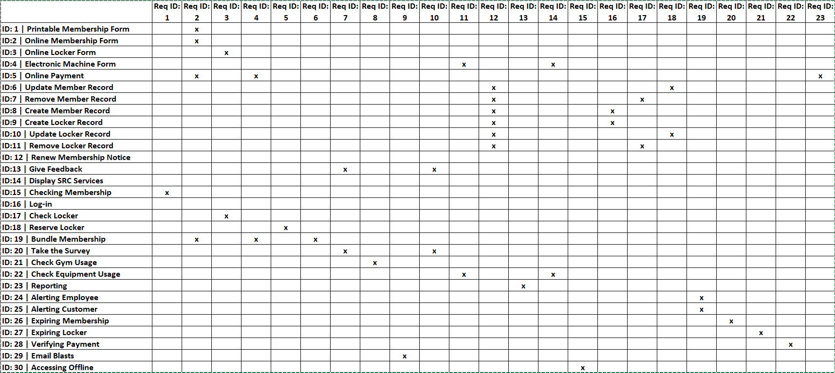

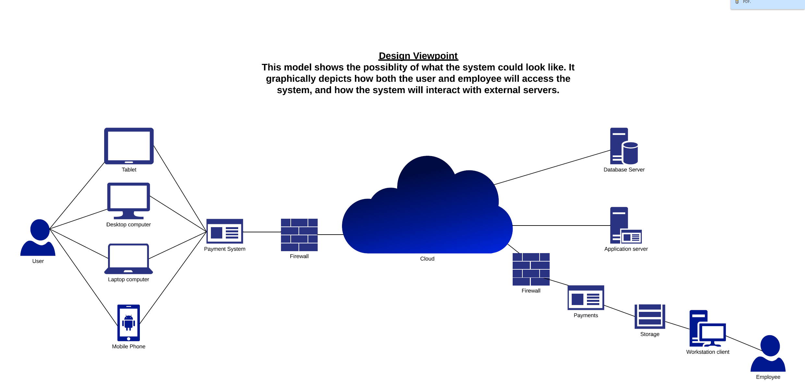

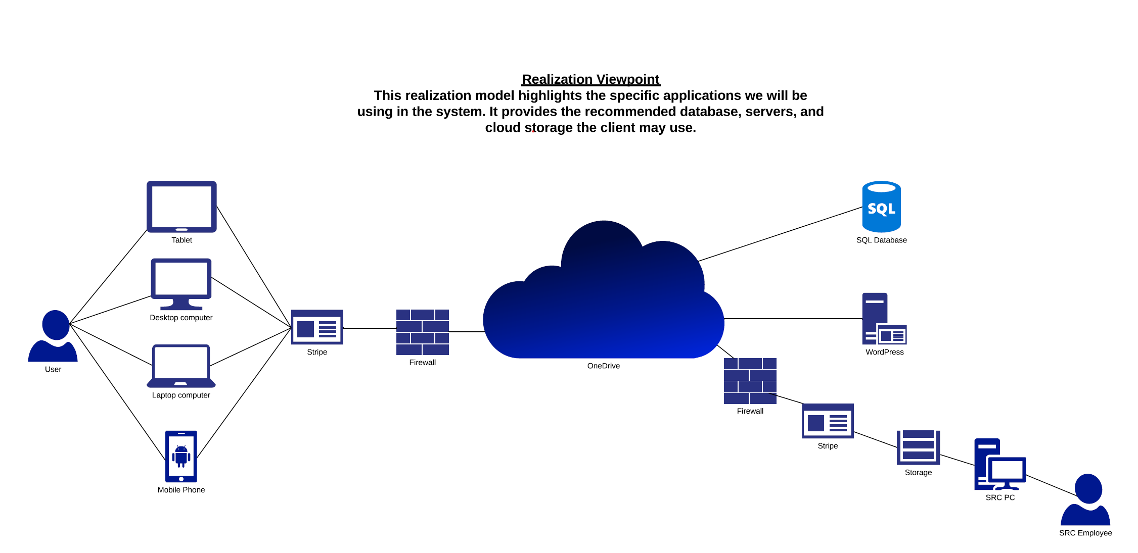

**Risk Analysis**

This is our risk analysis. This defines what is considered high and low risk with the to-be system, and pairs those defined risk levels to the specific use cases and system requirements.

**USE CASE RISK**

HIGH RISK – A high risk use case will be defined as a use case that if done incorrectly has the potential for non-recoverable loss of data, money, or a customer.

LOW RISK – A low risk use case will be defined as a use case that will cause an inconvenience for future operations, but no loss of data, money, or customers.

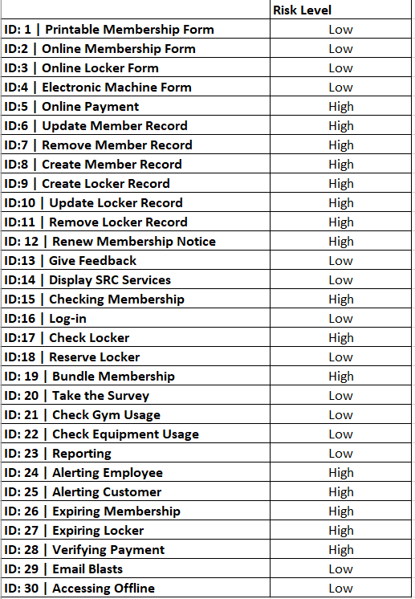

**OTHER RISK AREAS:**

HIGH RISK – Anything that will cause non-recoverable loss of data, money, or customers.

LOW RISK – Anything that will cause an inconvenience for future operations but no loss to data, money, or customers.

High risk items would include:

* The website being down.
* Database backup failure.
* Payment systems being compromised.
* Failure to deliver SRC services because of the system.

Low risk items would include:

* Human error when inputting names or information on forms before database input.
* Hardware malfunctions such as printers not working, or tablets not being charged.
* Failure to deliver customer feedback surveys.

During the Elaboration phase our job will be too determine ways to mitigate the high-risk areas of the system. We will be able to do this by making sure the staff is properly trained and understands how the system will work in order to reduce human error. Also, we will ensure that high-risk systems have proper backups in place that will offer redundancy. We will also confirm that the system requirements that throw errors through invalid entries, payment verification, and membership/expiration dates will work properly for possible scenarios.

Team Charter

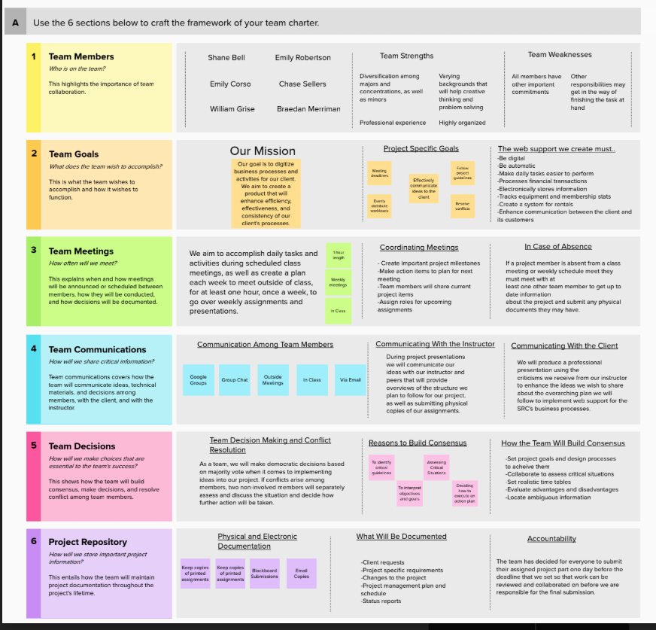

Gantt Chart

This Gantt Chart is used to depict the duration and overlap of the project tasks and deliverables. As seen below, to implement the business process solutions for the SRC the following deliverables are needed: Vision Document, Internal Architecture, Risk Analysis, System Requirements, Use Cases, Gantt Chart, and Inception Phase Prototypes. Each of these deliverables need to be completed within the window of September 5thth and October 15th. There are some deliverables that have a shorter window of time allotted to complete, and those are noted by the shorter lines. Additionally, there are many deliverables that need to be completed within the same window. This chart depicts how those specific deliverables are completed within the same amount of time. In some cases, all these deliverables must be completed by one team member, or in others, they are completed by many members. Depending on how responsibilities are divided, deliverables may by completed simultaneously or individually. Holistically, this chart can be used to keep track of how many deliverables are being in progress at one time, and when those deliverables need to completed to move on with the project at hand.

|  |  |  |  |  |
| --- | --- | --- | --- | --- |
| **Start Date** | **End Date** | **Duration in Days** | **Task ID** | **Deliverables** |
| 9/5/2019 | 10/2/2019 | 27 | 1 | Vision Document |
| 9/5/2019 | 10/4/2019 | 29 | 2 | Process Models |
| 9/17/2019 | 9/26/2019 | 9 | 3 | List of Use Cases |
| 9/17/2019 | 9/27/2019 | 10 | 4 | Inception Phase Protypes |
| 9/17/2019 | 9/30/2019 | 13 | 5 | System Requirements |
| 9/17/2019 | 10/3/2019 | 16 | 6 | Internal Architecture |
| 9/20/2019 | 9/26/2019 | 6 | 7 | Risk Analysis |
| 9/25/2019 | 10/4/2019 | 9 | 8 | Gantt Chart |
| 10/3/2019 | 10/15/2019 | 12 | 9 | Use Case Diagram |
| 10/6/2019 | 10/15/2019 | 9 | 10 | Use Case Prototype |

|  |  |  |
| --- | --- | --- |
| **Deliverables** | **Task Responsibility** | **Task Dependencies** |
| Vision Document | Emily Robertson | This document changes with every iteration and depends on most business tasks throughout the project |
| Process Models | Emily Corso | This task will depend on group decisions about processes but will have a set end date on October 4th |
| List of Use Cases | Will Grise | These Use Cases could not have been created without the completion of the process models and system requirements |
| Inception Phase Protypes | Chase Sellers & Braeden Merriman | These prototypes depend on the Use Cases and system requirements |
| System Requirements | Will Grise | The system requirements depend on input from the project manager and champion |
| Internal Architechture | Braeden Merriman | This document depended on the process models and prototypes |
| Risk Analysis | Shane Bell | This analysis was dependent on the use cases and system requirements |
| Gantt Chart | Emily Corso | The Gantt chart is dependent on all tasks and the schedule created by the project manager and champion |
| Use Case Diagram | Shane Bell | The Use Diagrams cannot be created without a completed list of the Use Cases |
| Use Case Prototype | Chase Sellers | The Use Case Prototype cannot be created without the completion of the diagram |
|  |  |  |

**Database View Prototype**

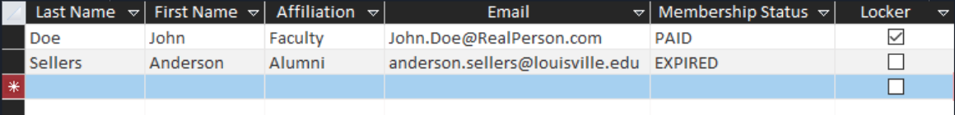

**Payment Form Prototype**

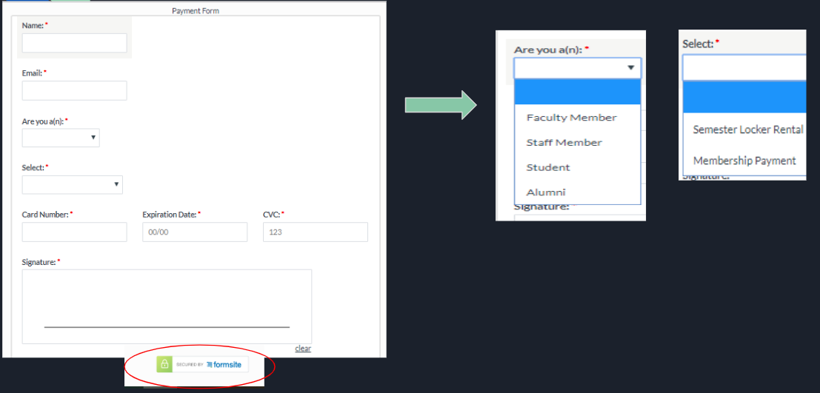

**Email Blast Prototype**

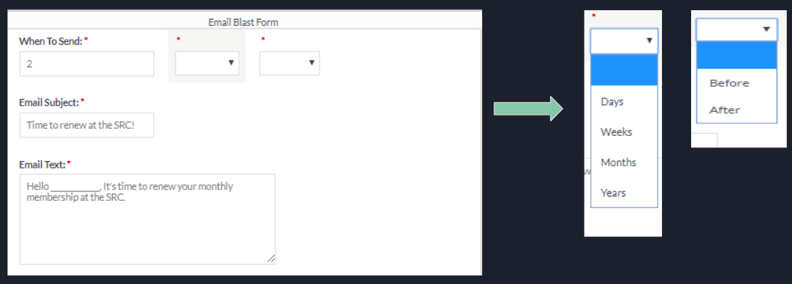

**Locker Rental Form Prototype**

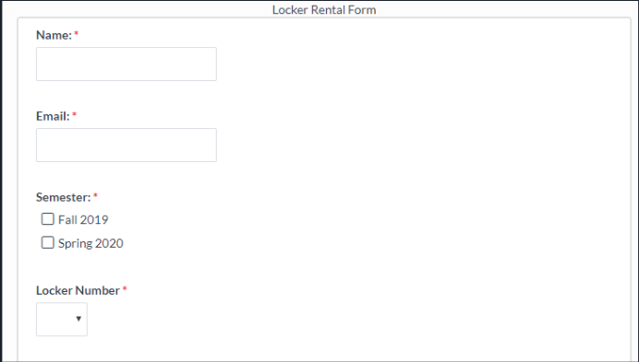

**Locker Selection View Prototype**

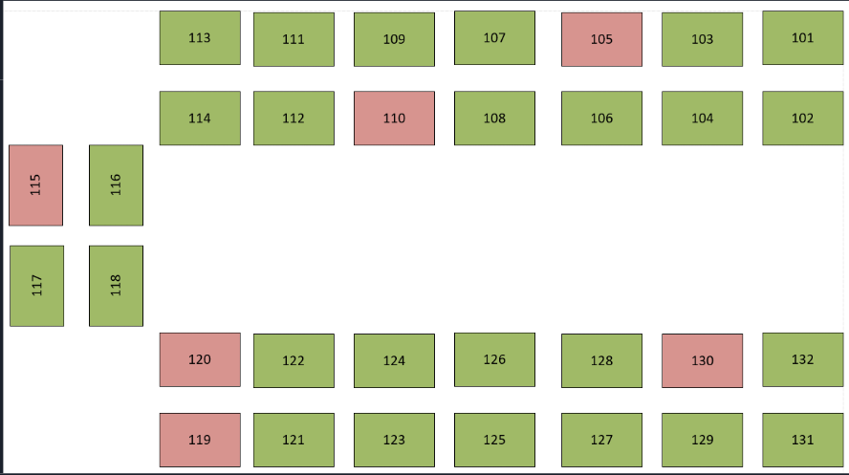

**Machine Report Prototype**

